Version 1.0



Photos and text input for your album

Save a copy of this file to your computer. This is one of two documents you need to complete for your album compile. The outward appearance of your album is selected in the album preferences document (separate download). Don’t forget to save this document each time you work on it and complete it at your leisure. Once you get started, you’ll find it is easy.
This document is for the selection of images for your album and text you want for captions and stories if any. You may need to use and return more copies of this document for a larger album or you can add more story-image-caption blocks to this document if you wish (read more below).
The use of this document is preferred over an automated on-line input system. It is seen that if anything happens to such a system at our end, your input could be at jeopardy. With this, you at least have the information in your possession for any occurrence and you don’t have to be online to use it.
Please note that you do get a copy of all the images files we process for you plus the originals, regardless of your selection here for the album.

How to use this input form
Select images and add stories and captions

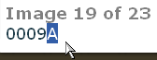 .. from your-photos web page, you may want: image 0009 version A.
Look at your photos web page <your-photos> and select images one by one in the order that you want them shown in your album. Enter the image numbers in the green form boxes below.
The image version is shown as F, D, A, B or C. Those marked F and D are your supplied film or digital image originals. Generally, you would want to choose the improved versions marked with an “A or B”. The level A fix is automatically processed. We may suggest and you confirm a further improvement of the image to a level B fix. There may be a later discount if using ‘B’ images in your album – refer to Pricing details on our home web page (subject to change). We may throw in a version C image at no further charge, just as an alternative you may prefer to the B version.

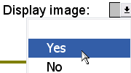 .. in green box.
Select “Yes” in the green box below for the image to appear. You may prefer later not to include the image or you may even use the green box for your own notes.
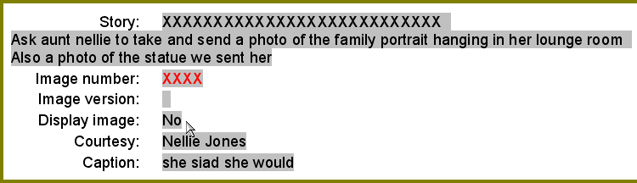
We only process images and text in the green box if the image therein is marked Yes. (The four red Xs is just our idea that may make it easier to find your notes if scrolling down the page quickly).

 .. copy caption from your-photos web page.
Type in a caption if wanted (or leave it blank, type nothing). You may already have a caption idea written in the image file name that appears in <your-photos> web page. You may have typed it into your digital photo file name before you sent it to us. You can copy and paste it if you like. (Incidentally, the “475” seen above is the number you may have given to the file name).
If you want the same caption to apply to the next image in your album, type the word “same” in the caption of that next green box and even the following green box image too if you like and so on. We will group the images with the one caption.
If you want a story to appear above a photo, type that in the green box too. Press ‘Enter’ on the keyboard to create a new paragraph in stories or captions. For no story, leave the Story field blank. (Tell us in the ‘Comments’ box of the album preferences document if you want to underline or otherwise format the first line in a story. Generally we don’t. You may prefer to speak with us to sort out some formatting changes).
If you want to acknowledge someone for providing the image to you, place their name in Courtesy or simply leave it blank.
Rearrange the order
A good practice is to leave every second green box empty (unused). It may help later if you need to change the order of images and text.
If you prefer, you can quickly change the order of green boxes and this is how you do it. Save the document before you start in case you get lost and need to revert back. (You may even want to save a copy of the document for safe keeping should something adverse happens). Then unprotect the document with the password “control”. You may see “Unprotect Document” if you click “Tools” at the top. Do not attempt to enter any of your album details while this document is unprotected. You simply want to rearrange the order of green boxes now.
With your mouse, left click and select (drag) from the space above the box to the bottom on the box (or boxes) and not the space below the last box you want to move.
SELECT 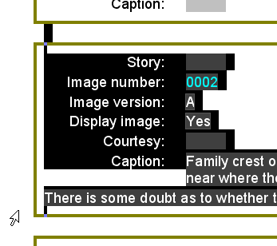 COPY
Then either right click anywhere and select Cut, or press Ctrl X on the keyboard. Move to a position in the document where you want the boxes moved to, left click in just the space above a green box there until the curser ‘blinks’, right click and select Paste (Ctrl V on the keyboard).
SELECT 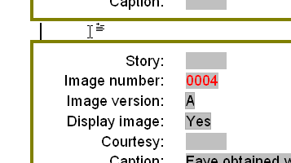 PASTE
blinkss
When you are happy with the rearranging of your green boxes, save the document and protect the document again. Use the same password “control” again, because when you send the file to us, we may need to use it. You can now start to enter information for your album again.
You may use this method to add more blank green boxes if you wish and you may also use this method to bring in green boxes from another one of these documents you may have started.
We do have checks in place to ensure the same image does not appear twice. If it does, we ask you if you wanted it that way.
When you feel this form is complete, send it to us and keep a copy yourself. We will advise you of when a preview is available on <your-album> web page. You can then adjust and send this form again if you like. We will again show you a preview and so on, until you are completely satisfied. We will then complete a full layout for you to approve before we print the album.
Please contact us if you need help with this document on 02 88125848.
Enjoy your archiving and thanks for your time completing this form.

Your customer ID: 1234

Album content

1. Title name on album to be: Jack and Jill Jones
2. This document is album:

Help with the numbered items above:
1. This should match the title name you have typed into the album preferences document. An example would be the names of you and your partner like Jack and Jill Jones but you may decide otherwise. In case you order a different album with of course a different title name, then we can be sure to insert the details of this document into the correct album.
2. You may require two or more of these input documents to complete one titled album. You may run out of green boxes to use in the one document and not want to add new green boxes. You may prefer separate documents for different occasions. We need to be sure all input into your album is placed in correct order, by the album input numbers shown here and in the subsequent documents despite the name you give to each document that you may have like this ...
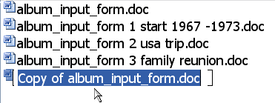

Start inserting details here in each image block for your album compile:

Story:
Image number:
Image version:
Display image:
Courtesy:
Caption:

Story:
Image number: 0003
Image version:
Display image:
Courtesy:
Caption: My note: Not sure if 0003A or 0003B is better

Story:
Image number:
Image version:
Display image:
Courtesy:
Caption:

Story: Our family tree shows that many of our ancestors resided in Europe.
In the 19th century, many of them spread throughout the world travelling by ships to far lands including Australia.
Image number: 0003
Image version:
Display image:
Courtesy: H Nebuchadnezzar
Caption: My great great grandmother Faye Dunkin fourth from the left sitting, 6 years old at school in France.

Story:
Image number:
Image version:
Display image:
Courtesy:
Caption:

Story:
Image number: 0004
Image version:
Display image:
Courtesy:
Caption: Faye obtained work in Malaysia and wrote this note to her son Jimmy,

Story:
Image number:
Image version:
Display image:
Courtesy:
Caption:

Story:
Image number: 0002
Image version:
Display image:
Courtesy:
Caption: Family crest obtained from a store by the Tigris River on a recent trip there, near where the Hanging Gardens of Babylon used to be.
There is some doubt as to whether this crest is authentic or not.

Story:
Image number:
Image version:
Display image:
Courtesy:
Caption:

Story: Sydney Australia
Jim Nebuchadnezzar settled here in 1851.
He was a drifter for some time before he bought a home in St Ives in Sydney.
Image number: 0009
Image version:
Display image:
Courtesy:
Caption: St Ives home

Story:
Image number:
Image version:
Display image:
Courtesy:
Caption:

Story:
Image number: 0008
Image version:
Display image:
Courtesy:
Caption:

Story:
Image number:
Image version:
Display image:
Courtesy:
Caption:

Story:
Image number: 0008
Image version:
Display image:
Courtesy:
Caption:

Story:
Image number: 0011
Image version:
Display image:
Courtesy:
Caption: A surviving drawing of Jimmy back in Europe.

Story:
Image number:
Image version:
Display image:
Courtesy:
Caption:

Story:
Image number: 0011
Image version:
Display image:
Courtesy:
Caption:

Story:
Image number:
Image version:
Display image:
Courtesy:
Caption:

Story:
Image number: 0006
Image version:
Display image:
Courtesy:
Caption: Newspaper clippings found in Jimmy’s belongings. His son Eddy was a keen musician and often played in gigs around the Eastern suburbs of Sydney.

Story:
Image number:
Image version:
Display image:
Courtesy:
Caption:

Story:
Image number: 0007
Image version:
Display image:
Courtesy:
Caption:

Story:
Image number:
Image version:
Display image:
Courtesy:
Caption:

Story:
Image number: 0005
Image version:
Display image:
Courtesy:
Caption: Eddy’s very happy daughter Sian.
Her pet dog “Pinny” seemed disinterested in her painted face.

Story:
Image number:
Image version:
Display image:
Courtesy:
Caption:

Story:
Image number: 0010
Image version:
Display image:
Courtesy: Victor Rayson
Caption: Brendan and Jackson step brothers.

Story:
Image number:
Image version:
Display image:
Courtesy:
Caption:

Story:
Image number:
Image version:
Display image:
Courtesy:
Caption:

Story:
Image number:
Image version:
Display image:
Courtesy:
Caption:

Story:
Image number:
Image version:
Display image:
Courtesy:
Caption:

Story:
Image number:
Image version:
Display image:
Courtesy:
Caption:

Story:
Image number:
Image version:
Display image:
Courtesy:
Caption:

Story:
Image number:
Image version:
Display image:
Courtesy:
Caption:

Story:
Image number:
Image version:
Display image:
Courtesy:
Caption:

Story:
Image number:
Image version:
Display image:
Courtesy:
Caption:

