Version 1.0



Album preferences and family tree option

Save a copy of this file to your computer. This is one of two documents you need to complete for your album compile. The selection of images and any text for stories and captions is created in the album input document (separate download). There is only the need to use this document once for one titled album. It deals with the ‘look’ of your intended album, and whether or not you want one or more family trees within your album. Don’t forget to save this file each time you work on it.
When you feel this form is complete, send it to us and keep a copy yourself. We will advise you of when a preview is available on <your-album> web page. You can then adjust and send this form again if you like. We will again show you a preview and so on, until you are completely satisfied. We will then complete a full layout of the album for you to approve before we print the album.
Please contact us if you need any help with this document.
Enjoy your archiving and thanks for your time completing this form.

Your customer ID: 1234

Album preferences

1. Title name on album to be: Jack and Jill Jones
2. Select your preferred album type:
3. Select your preferred album colour:
4. Select an album title page design:
5. Show “Compiled by” name:
6. If yes, “Compiled by” who: Andrew Dunkin
7. Show “Printed on” date:
8. Comments: please underline the first line of every story, thank you

Help with the numbered items above:
1. Your ‘title name’ on your album is shown within the title page design (3) seen on the leading page of your album. The same title page and name will be shown on the cover of an adjustable album and the name on the spine. For a hard cover album, the name in CAPITAL letters will be shown on the front cover and spine. The spine is the side of the album. You title name should match the name provided in the album input document (separate download).
2. 3. and 4. Refer to our <album_design> web page to help select these answers. There is a link to it from <your-album> web page.
5. 6. and 7. If someone inherits your family archive album, or two or more copies are made of the album, we suggest that you show the name of who compiled the album and the printing date, faintly on top of each page of the album like this:
Compiled by (you) Printed 29/07/2026
If one or more pages in an album are updated sometime, it may later help people determine which album version has the updated details and by whom.
8. Comments can be anything like your questions, requests or feedback to ArcAm.
The default font for text in the album pages is Arial size 10 and for the image file numbers is Arial size 9. This looks very good but you may want it differently. You may want the first line of a story or all stories to be underlined. We will do a spell check for you in Australian English unless you advise otherwise. You may want the same family tree to appear in two different albums. Anything at all that we can help you with. If nothing, just leave Comments blank.

Family tree

9. Family tree:
10. Title for family tree: Family Tree - Jack Jones and Jill Smith
11. Comments: please add a note under the tree "Debbie Jones was adopted"

A family tree is generally placed on the first page of your album but you can ask for a different location in the comments box above. The idea is to have a family tree for one couple, their parents and up to ten of your children. If either parent has children by another partner, a second family tree should be created using the next form section below the first. The second tree will appear on an album page after the first tree unless otherwise directed.
This document can be used for up to five family trees and sent to us for formatting. What you type into the form is shown exactly in the tree. Contact us if more than five family trees are wanted or a mother has more than 10 children!
Help with the numbered items above:
9. If you want the family tree, select which tree this is, first, second or third etc. If you wish to create and print a family tree yourself for an adjustable archive album, then there is an option to have us leave a pocket in the album empty for you to insert it. A spare pocket is available in an adjustable archive album only, not a hard cover book.
10. Your family tree title appears on the page directly above the tree. For example, you can type ‘Family Tree – Jack Jones and Jill Smith’ or simply ‘Jack and Jill Jones’.
11. Comments can be anything like questions, requests or feedback to us. For example, you may prefer no colour in the name boxes of the family tree or you may want a family tree to appear on a different page or in a different album. Please note that birth and death dates are limited to year only. Contact us if you require day and month also and we will work on it.
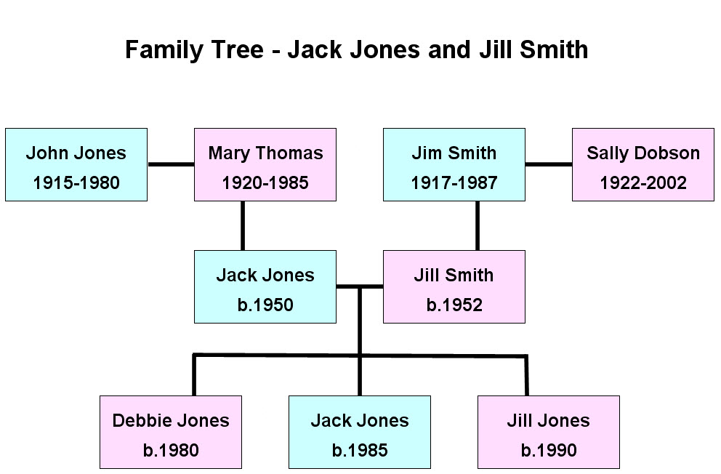
Debbie Jones was adopted

Start here to provide details of your first or only family tree:
Your particulars:

First name(s): Jack
Last name: Jones
Gender:
Year born: 1950
Year died:

Your partner

First name(s): Jill
Last name: Smith
Gender:
Year born: 1950
Year died:

Your father

First name(s): John
Last name: Jones
Gender:
Year born: 1910
Year died: 1980

Your mother

First name(s): Mary
Last name: Thomas
Gender:
Year born: 1910
Year died: 1980

Your partner’s father

First name(s): Jim
Last name: Smith
Gender:
Year born: 1912
Year died: 1982

Your partner’s mother

First name(s): Sally
Last name: Dobson
Gender:
Year born: 1912
Year died: 1982

Your child 1

First name(s): Debbie
Last name: Jones
Gender:
Year born: 1980
Year died:

Your child 2

First name(s): Jack
Last name: Jones
Gender:
Year born: 1985
Year died:

Your child 3

First name(s): Jill
Last name: Jones
Gender:
Year born: 1990
Year died:

Your child 4

First name(s):
Last name:
Gender:
Year born:
Year died:

Your child 5

First name(s):
Last name:
Gender:
Year born:
Year died:

Your child 6

First name(s):
Last name:
Gender:
Year born:
Year died:

Your child 7

First name(s):
Last name:
Gender:
Year born:
Year died:

Your child 8

First name(s):
Last name:
Gender:
Year born:
Year died:

Your child 9

First name(s):
Last name:
Gender:
Year born:
Year died:

Your child 10

First name(s):
Last name:
Gender:
Year born:
Year died:

Family tree two

9. Family tree:
10. Title for family tree:
11. Comments:

Help with the numbered items above:
9. If you want the family tree, select which tree this is, first, second or third etc. If you wish to create and print a family tree yourself for an adjustable archive album, then there is an option to have us leave a pocket in the album empty for you to insert it. A spare pocket is available in an adjustable archive album only, not a hard cover book.
10. Your family tree title appears on the page directly above the tree. For example, you can type ‘Family Tree – Jack and Jill Jones’ or simply ‘Jack and Jill Jones’.
11. Comments can be anything like questions, requests or feedback to us. For example, you may prefer no colour in the name boxes of the family tree or you may want a family tree to appear on a different page or in a different album. Please note that birth and death dates are limited to year only. Contact us if you require day and month also and we will work on it.
Start here to provide details of your next family tree:
Your particulars:

First name(s):
Last name:
Gender:
Year born:
Year died:

Your partner

First name(s):
Last name:
Gender:
Year born:
Year died:

Your father

First name(s):
Last name:
Gender:
Year born:
Year died:

Your mother

First name(s):
Last name:
Gender:
Year born:
Year died:

Your partner’s father

First name(s):
Last name:
Gender:
Year born:
Year died:

Your partner’s mother

First name(s):
Last name:
Gender:
Year born:
Year died:

Your child 1

First name(s):
Last name:
Gender:
Year born:
Year died:

Your child 2

First name(s):
Last name:
Gender:
Year born:
Year died:

Your child 3

First name(s):
Last name:
Gender:
Year born:
Year died:

Your child 4

First name(s):
Last name:
Gender:
Year born:
Year died:

Your child 5

First name(s):
Last name:
Gender:
Year born:
Year died:

Your child 6

First name(s):
Last name:
Gender:
Year born:
Year died:

Your child 7

First name(s):
Last name:
Gender:
Year born:
Year died:

Your child 8

First name(s):
Last name:
Gender:
Year born:
Year died:

Your child 9

First name(s):
Last name:
Gender:
Year born:
Year died:

Your child 10

First name(s):
Last name:
Gender:
Year born:
Year died:

Family tree three

9. Family tree:
10. Title for family tree:
11. Comments:

Help with the numbered items above:
9. If you want the family tree, select which tree this is, first, second or third etc. If you wish to create and print a family tree yourself for an adjustable archive album, then there is an option to have us leave a pocket in the album empty for you to insert it. A spare pocket is available in an adjustable archive album only, not a hard cover book.
10. Your family tree title appears on the page directly above the tree. For example, you can type ‘Family Tree – Jack and Jill Jones’ or simply ‘Jack and Jill Jones’.
11. Comments can be anything like questions, requests or feedback to us. For example, you may prefer no colour in the name boxes of the family tree or you may want a family tree to appear on a different page or in a different album. Please note that birth and death dates are limited to year only. Contact us if you require day and month also and we will work on it.
Start here to provide details of your next family tree:
Your particulars:

First name(s):
Last name:
Gender:
Year born:
Year died:

Your partner

First name(s):
Last name:
Gender:
Year born:
Year died:

Your father

First name(s):
Last name:
Gender:
Year born:
Year died:

Your mother

First name(s):
Last name:
Gender:
Year born:
Year died:

Your partner’s father

First name(s):
Last name:
Gender:
Year born:
Year died:

Your partner’s mother

First name(s):
Last name:
Gender:
Year born:
Year died:

Your child 1

First name(s):
Last name:
Gender:
Year born:
Year died:

Your child 2

First name(s):
Last name:
Gender:
Year born:
Year died:

Your child 3

First name(s):
Last name:
Gender:
Year born:
Year died:

Your child 4

First name(s):
Last name:
Gender:
Year born:
Year died:

Your child 5

First name(s):
Last name:
Gender:
Year born:
Year died:

Your child 6

First name(s):
Last name:
Gender:
Year born:
Year died:

Your child 7

First name(s):
Last name:
Gender:
Year born:
Year died:

Your child 8

First name(s):
Last name:
Gender:
Year born:
Year died:

Your child 9

First name(s):
Last name:
Gender:
Year born:
Year died:

Your child 10

First name(s):
Last name:
Gender:
Year born:
Year died:

Family tree four

9. Family tree:
10. Title for family tree:
11. Comments:

Help with the numbered items above:
9. If you want the family tree, select which tree this is, first, second or third etc. If you wish to create and print a family tree yourself for an adjustable archive album, then there is an option to have us leave a pocket in the album empty for you to insert it. A spare pocket is available in an adjustable archive album only, not a hard cover book.
10. Your family tree title appears on the page directly above the tree. For example, you can type ‘Family Tree – Jack and Jill Jones’ or simply ‘Jack and Jill Jones’.
11. Comments can be anything like questions, requests or feedback to us. For example, you may prefer no colour in the name boxes of the family tree or you may want a family tree to appear on a different page or in a different album. Please note that birth and death dates are limited to year only. Contact us if you require day and month also and we will work on it.
Start here to provide details of your next family tree:
Your particulars:

First name(s):
Last name:
Gender:
Year born:
Year died:

Your partner

First name(s):
Last name:
Gender:
Year born:
Year died:

Your father

First name(s):
Last name:
Gender:
Year born:
Year died:

Your mother

First name(s):
Last name:
Gender:
Year born:
Year died:

Your partner’s father

First name(s):
Last name:
Gender:
Year born:
Year died:

Your partner’s mother

First name(s):
Last name:
Gender:
Year born:
Year died:

Your child 1

First name(s):
Last name:
Gender:
Year born:
Year died:

Your child 2

First name(s):
Last name:
Gender:
Year born:
Year died:

Your child 3

First name(s):
Last name:
Gender:
Year born:
Year died:

Your child 4

First name(s):
Last name:
Gender:
Year born:
Year died:

Your child 5

First name(s):
Last name:
Gender:
Year born:
Year died:

Your child 6

First name(s):
Last name:
Gender:
Year born:
Year died:

Your child 7

First name(s):
Last name:
Gender:
Year born:
Year died:

Your child 8

First name(s):
Last name:
Gender:
Year born:
Year died:

Your child 9

First name(s):
Last name:
Gender:
Year born:
Year died:

Your child 10

First name(s):
Last name:
Gender:
Year born:
Year died:

Family tree five

9. Family tree:
10. Title for family tree:
11. Comments:

Help with the numbered items above:
9. If you want the family tree, select which tree this is, first, second or third etc. If you wish to create and print a family tree yourself for an adjustable archive album, then there is an option to have us leave a pocket in the album empty for you to insert it. A spare pocket is available in an adjustable archive album only, not a hard cover book.
10. Your family tree title appears on the page directly above the tree. For example, you can type ‘Family Tree – Jack and Jill Jones’ or simply ‘Jack and Jill Jones’.
11. Comments can be anything like questions, requests or feedback to us. For example, you may prefer no colour in the name boxes of the family tree or you may want a family tree to appear on a different page or in a different album. Please note that birth and death dates are limited to year only. Contact us if you require day and month also and we will work on it.
Start here to provide details of your next family tree:
Your particulars:

First name(s):
Last name:
Gender:
Year born:
Year died:

Your partner

First name(s):
Last name:
Gender:
Year born:
Year died:

Your father

First name(s):
Last name:
Gender:
Year born:
Year died:

Your mother

First name(s):
Last name:
Gender:
Year born:
Year died:

Your partner’s father

First name(s):
Last name:
Gender:
Year born:
Year died:

Your partner’s mother

First name(s):
Last name:
Gender:
Year born:
Year died:

Your child 1

First name(s):
Last name:
Gender:
Year born:
Year died:

Your child 2

First name(s):
Last name:
Gender:
Year born:
Year died:

Your child 3

First name(s):
Last name:
Gender:
Year born:
Year died:

Your child 4

First name(s):
Last name:
Gender:
Year born:
Year died:

Your child 5

First name(s):
Last name:
Gender:
Year born:
Year died:

Your child 6

First name(s):
Last name:
Gender:
Year born:
Year died:

Your child 7

First name(s):
Last name:
Gender:
Year born:
Year died:

Your child 8

First name(s):
Last name:
Gender:
Year born:
Year died:

Your child 9

First name(s):
Last name:
Gender:
Year born:
Year died:

Your child 10

First name(s):
Last name:
Gender:
Year born:
Year died:

